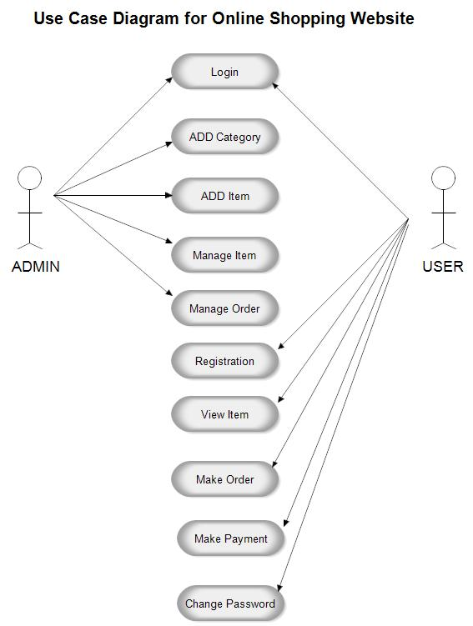

|  |  |  |
| --- | --- | --- |
| Use Case | Actor | Description |
| 1.Login | Admin And User | 1.Login done by admin and user to admin |
| 2.Add Category | Admin | Addition of new category is only add by admin |
| 3.Add Item | Admin | Addition of new item in shopping side is done by admin |
| 4.Mange Item and Orders | Admin | Mange items and orders such as addition of items and cancels of orders |
| 5.Regstration | Admin and user | Registration is handle by user and admin also |
| 6.View Items | Admin and user | User are able to view items according to need |
| 7.Make Order and Payment | Admin and User | Making order and payment it also handle by sdmin |

**Use case Description**

**Use Case 001:Login**

1. **Introduction:**

This use case outline the steps that need to be followed in order to add category

1. **Actors:**

* Admin
* User

1. **Pre-Condition:**

The admin have valid credentials

1. **Scenario:**

|  |  |  |
| --- | --- | --- |
| **Sr** | **Action** | **Software** |
| **1.** | Login to the system | System request the following data  1.User id  2.Password |
| **2.** | **Use fill out data** | The System verifies that the above items have been filled out If any data is missing,  the system warms the user and the scenario continues with software reaction |
|  |  |  |

1. **Post-condition**

If use case is successfully executed, the user should login to the application

1. **Basic Flow:**

**Login**

1. The page will request the admin to provide valid credentials
2. Admin enters into the system
3. **Alternate Flow:**

**1.Invaild Credentials:**

If actor provides invalid credentials in the basic flow, a validation message or error message should appear. Hence, returning the /actor to the basic flow...

1. **Special Requirement:**

None

1. **Associated Use Case(S)**

None

.

**Use Case 002:Add category**

1. **Introduction:**

This use case outline the steps that need to be followed in order to login into the system

1. **Actors:**

* Admin

1. **Pre-Condition:**

The admin have valid credentials

1. **Scenario:**

|  |  |  |
| --- | --- | --- |
| **Sr** | **Action** | **Software** |
| **1.** | Add category | System request to admin to add category  Need authentication |
| **2.** | **fill out data** | The System verifies that the above items have been filled out If any data is missing,  the system warms the user and the scenario continues with software reaction  If all data has been entered, the System asks the users to verify dashboard If the user indicates they would like to cancel the scenario end here |
| **3.** | confirms that their selected category is correct | If the admin indicates that their selected student is correct the scenarios continues with the software reaction |

1. **Post-condition**

If use case is successfully executed, the admin should add new categories in applications

1. **Basic Flow:**

**Add Category**

1. enter into system
2. makes change add new category
3. **Alternate Flow:**

**1.Invaild Credentials:**

If admin/actor provides invalid credentials in the basic flow, a validation message or error message should appear. Hence, returning the admin/actor to the basic flow...

1. **Special Requirement:**

None

1. **Associated Use Case(S)**

None

**Use Case 003:Add items**

1. **Introduction:**

This use case outline the steps that need to be followed in order to login into the system

1. **Actors:**

* Admin

1. **Pre-Condition:**

The admin have valid credentials

1. **Scenario:**

|  |  |  |
| --- | --- | --- |
| **Sr** | **Action** | **Software** |
| **1.** | Add items | System request to admin to add item  Need authentication  Item should be available |
| **2.** | Admin fill out data | The System verifies that the above items have been filled out If any data is missing,  the system warms the user and the scenario continues with software reaction  If all data has been entered, the System asks the users to verify dashboard If the user indicates they would like to cancel the scenario end here |
| **3.** | Admin confirms that their selected item is correct | If the admin indicates that their selected student is correct the scenarios continues with the software reaction |

1. **Post-condition**

If use case is successfully executed, the admin should add new items in applications

1. **Basic Flow:**

**Add Category**

1. enter into system
2. makes change add new items
3. **Alternate Flow:**

**1.Invaild Credentials:**

If admin/actor provides invalid credentials in the basic flow, a validation message or error message should appear. Hence, returning the admin/actor to the basic flow.

1. **Special Requirement:**

Items are available

1. **Associated Use Case(S)**

None

**Use Case 004:Manage items and orders**

1. **Introduction:**

This use case outline the steps that need to be followed in order to manage items and orders

1. **Actors:**

* Admin

1. **Pre-Condition:**

The admin have valid credentials

1. **Scenario:**

|  |  |  |
| --- | --- | --- |
| **Sr** | **Action** | **Software** |
| **1.** | Manage items | System request to admin to add item  Need authentication  Item should be available in stocks  If item not available it should display out of stock |
| **2.** | Manage Order | System request to admin to add item  Need authentication  If lost of order are occurs it should be mange by admin  Order address should be correct with right phone no |
| **3.** | Admin fill out data | The System verifies that the above items have been filled out If any data is missing,  the system warms the user and the scenario continues with software reaction  If all data has been entered, the System asks the users to verify dashboard If the user indicates they would like to cancel the scenario end here |
| **3.** | Admin confirms that their selected item and is correct | If the admin indicates that their selected student is correct the scenarios continues with the software reaction |

1. **Post-condition**

If use case is successfully executed, the admin should add new items in applications

1. **Basic Flow:**

**Manage items and Orders**

1. enter into system
2. makes change add new items
3. Orders with correct
4. **Alternate Flow:**

**1.Invaild Credentials:**

If admin/actor provides invalid credentials in the basic flow, a validation message or error message should appear. Hence, returning the admin/actor to the basic flow.

1. **Special Requirement:**

**None**

1. **Associated Use Case(S)**

None

**Use Case 005:Regstration**

1. **Introduction:**

This use case outline the steps that need to be followed in with regstration

1. **Actors:**

* Admin
* User

1. **Pre-Condition:**

The admin and user have valid credentials

1. **Scenario:**

|  |  |  |
| --- | --- | --- |
| **Sr** | **Action** | **Software** |
| **1.** | Regstration | System request to admin to add item  1.Name  2. Mobile no  3.Address  4.Username  5.Password |
| **3.** | User and admin fill out | The System verifies that the above items have been filled out If any data is missing,  the system warms the user and the scenario continues with software reaction |

1. **Post-condition**

If use case is successfully executed, the admin should add new items in applications

1. **Basic Flow:**

**Regstration**

1. enter into system
2. Enter the details
3. **Alternate Flow:**

**1.Invaild Credentials:**

If admin/actor provides invalid credentials in the basic flow, a validation message or error message should appear. Hence, returning the admin/actor to the basic flow.

1. **Special Requirement:**

**None**

1. **Associated Use Case(S)**

None